Team Red – Task 5

# Task specification:

## Task description

1. Based on the review categories given in script 03.07 on slide 2, conduct a requirements review of the requirements document from Task 4 **-> Team Red evaluates work of team Green**
2. Document your results in a short review report table (approx. 1 page), including recommendations how the requirements document could be improved.

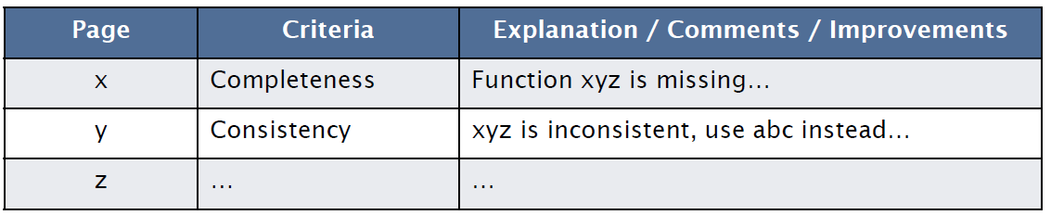

1. Award an overall grade to the report: 0-10 points
2. Send report to reviewed team

## Skript 03.07: Evaluation of a requirements document

* **Comprehensibility:** Is the requirement properly understood
* **Validity:** Will the system provide the functions which best support the customer’s needs
* **Consistency:** Are there any requirement conflicts
* **Completeness:** Are all functions required by the customer included
* **Realism:** Can the requirements be implemented given available budget and technology
* **Verifiability:** Can the requirements be checked
* **Traceability:** Is the origin of the requirement clearly stated
* **Adaptability:** Can the requirement be changed without a large impact on other requirements?

How can we validate requirements? **-> E.g. Weighted Point Evaluation system**

# Task solution

## Functional User requirements

|  |  |  |
| --- | --- | --- |
| Req # | Category | Comment |
| 10 | Realism | Health visitors don't have access to a Patient's File, such uploads must be validated by a doctor. |
| 12 | Validity | As doctors aren't primarily users of the program, they will not participate in the chat, consider using a mailing system (e.g. with additional options) instead. |
| 9 | Realism | Almost impossible to realise respecting data protection act. (any such publication must be approved by the patient) |
| 17 | Completeness | Consider making a general 'contacts' page that can be extended to multiple purpose. |
| 18 | Consistency | This event sould not be related to a visit, a section "accomondation" in patient's documentation might be more efficient. |
| ALL | Consistency | Mentionning 13 makes mentionning 16 unnecessary |
| ALL | Completeness | Not mentionned that the user wants to initially create appointments in their timetable. See 15, 21, 22 |

## Non Functional User requirements

|  |  |  |
| --- | --- | --- |
| Req # | Category | Comment |
| 2 | Verifiability | Provide a server/system up time in % |
| 3 | Traceability | Consider mentionning that parts like the alarm button must be perfectly reliable not the whole application (testing effort). |
| 6 | Verifiability | Not verifiable, consider "modular architecture" or "plugin supporting architecture" |
| ALL | Completeness | Should state on what device types the application runs |

## Functional System requirements

|  |  |  |
| --- | --- | --- |
| Req # | Category | Comment |
| 2 | Comprehensibility | It's not clear what data is mentionned here. If this refers to the backup case of 1, this should be clearly stated. |
| 8 | Verifyability | What kinds of exports / imports should be supported (e.g. print, scan, file types). |
| 4 | Verifyability | Mention what functions must be accessible by web (defines costs). |
| 7 | Completeness | Also mention the need for user groups with different access right (administrators, dept. leaders, health visitors). |

## Non Functional System requirements

|  |  |  |
| --- | --- | --- |
| Req # | Category | Comment |
| 1 | Verifiability | Specify what kind of attacks, measures |
| 2 | Verifiability | Provide a server/system up time in % |
| 4 | Realsim | Not all Data is available offline due to storage. Instead of "most recent data" it should be stated "recently used data" (i.e. caching). |
| 5 | Comprehensibility | Not stated if small or big error tolerance or which context. |
| 6 | Verifiability | Not verifiable, consider "modular architecture" or "plugin supporting architecture" |
| 7 | Verifiability | Consider mentionning the kind of interfaces to provide (web service, api). |